**“AITor” - EDUCATION PLATFORM – A PERSONALIZED STUDENT PERFORMANCE ANALYZER AND RECOMMENDATION SYSTEM**

2022-017

Project Status Document - 1

Liyanage M.L.A.P.– IT19120812

B.Sc. (Hons) in Information Technology specializing in Software Engineering

Department of Software Engineering

Sri Lanka Institute of Information Technology

Sri Lanka

January 2022

# DECLARATION

We declare that this is our own work, and this proposal does not incorporate without acknowledgement any material previously submitted for a degree or diploma in any other university or Institute of higher learning and to the best of our knowledge and belief it does not contain any material previously published or written by another person except where the acknowledgement is made in the text.

|  |  |  |
| --- | --- | --- |
| Name | Student ID | Signature |
| Liyanage M.L.A.P. | IT19120812 |  |

The above candidates are carrying out research for the undergraduate Dissertation

under my supervision.

Date:

05/13/2022

Contents

DECLARATION 2

1. Microsoft Teams chats and Meetings with supervisor/co-supervisor/external supervisor 5

1.1. Initial Teams group creation 5

1.2. Research team members only MS teams creation 5

1.3. Initial whats app group creation 5

2. Scheduled teams discussions 5

2.1. Bi-weekly Group only discussions 8

2.2. Meetings with external supervisor 9

3. Project planner 11

4. Project Gantt chart 12

5. Work breakdown chart 13

# Microsoft Teams chats and Meetings with supervisor/co-supervisor/external supervisor

## Initial Teams group creation

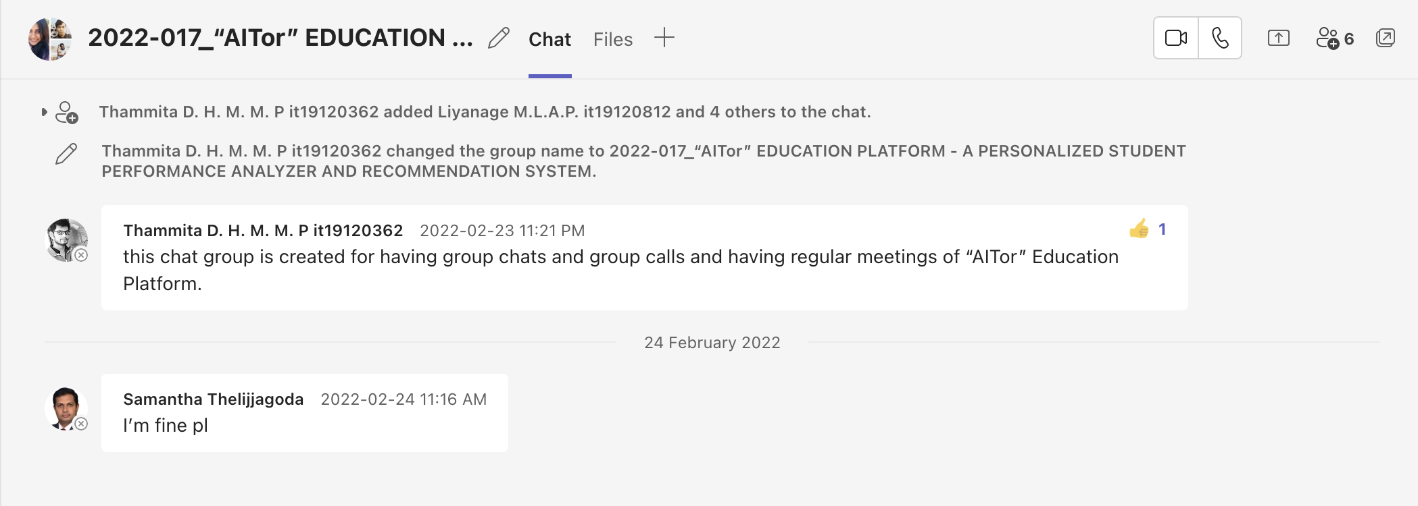

## Research team members only MS teams creation

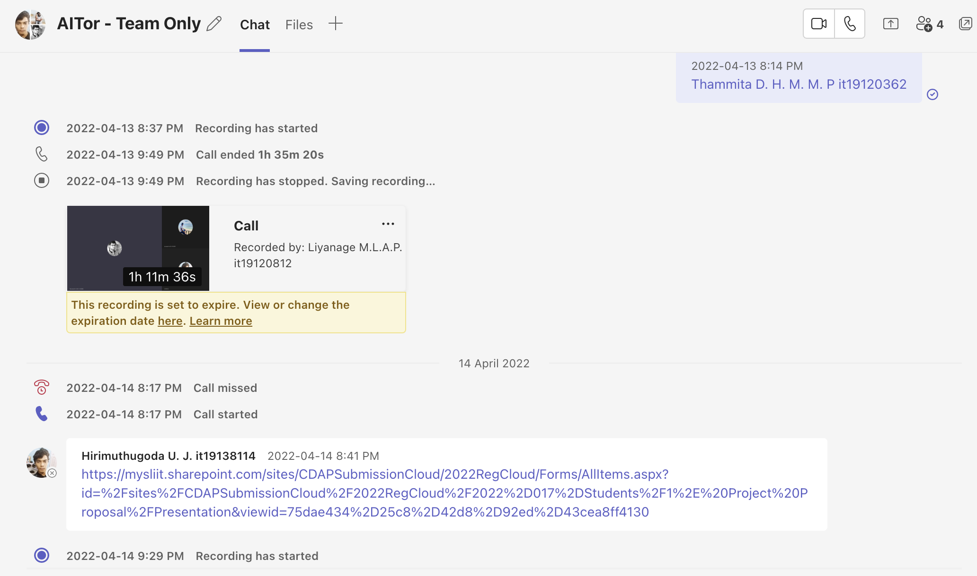

## Initial whats app group creation

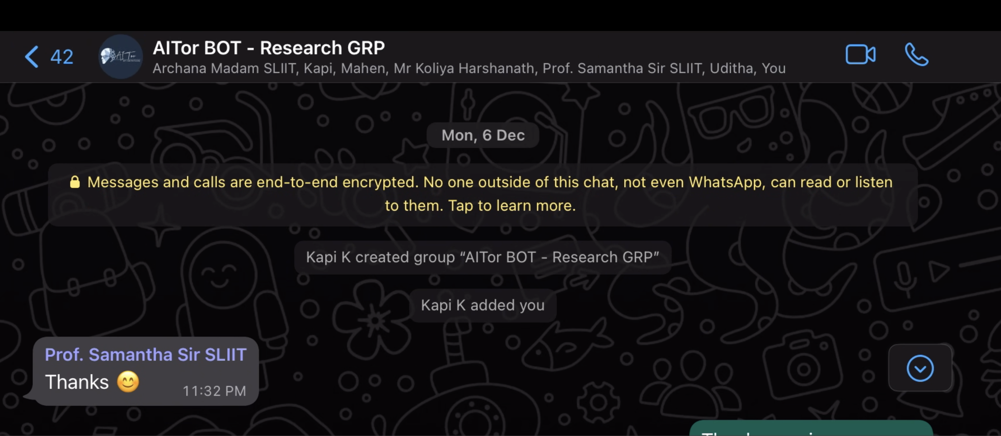

# Scheduled teams discussions

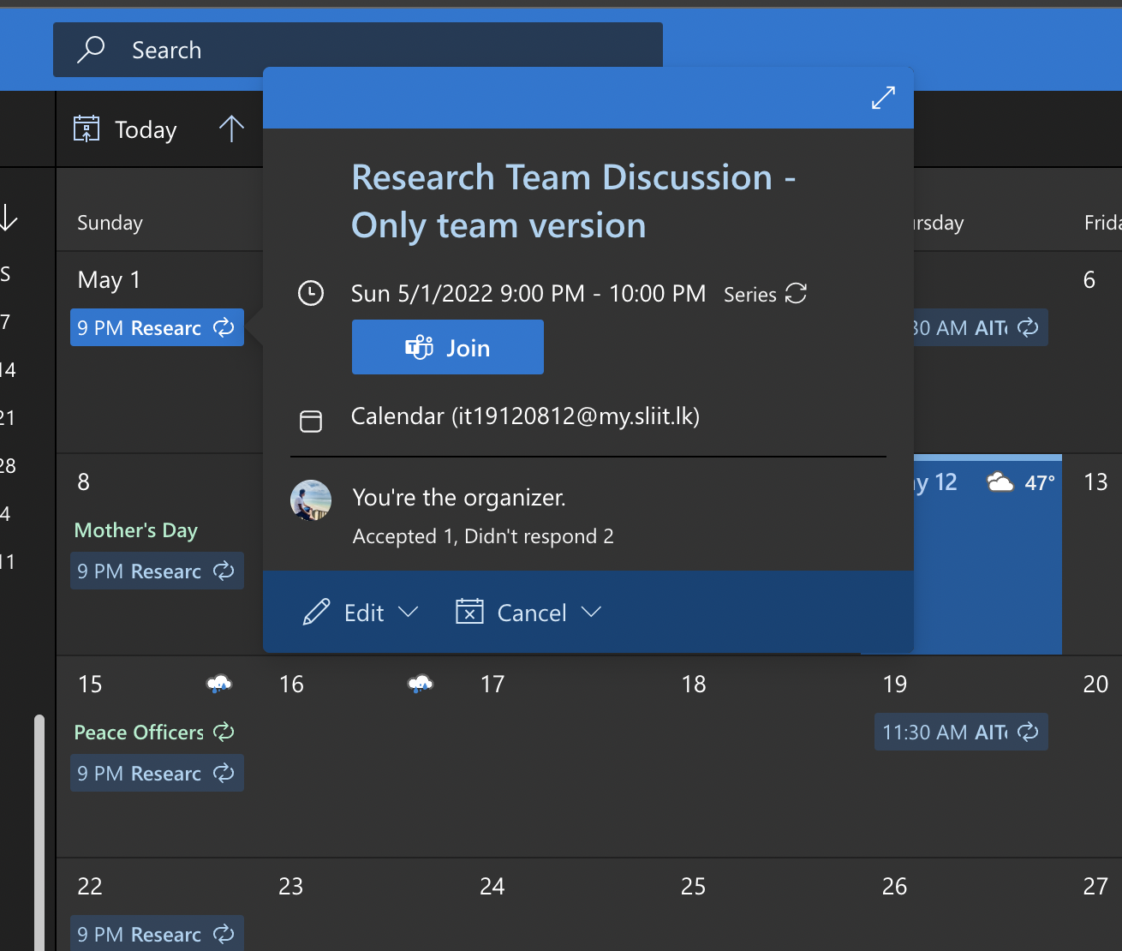

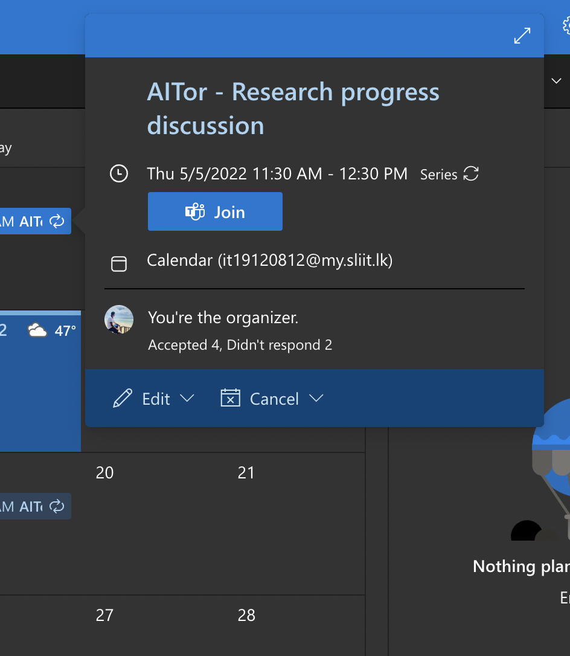

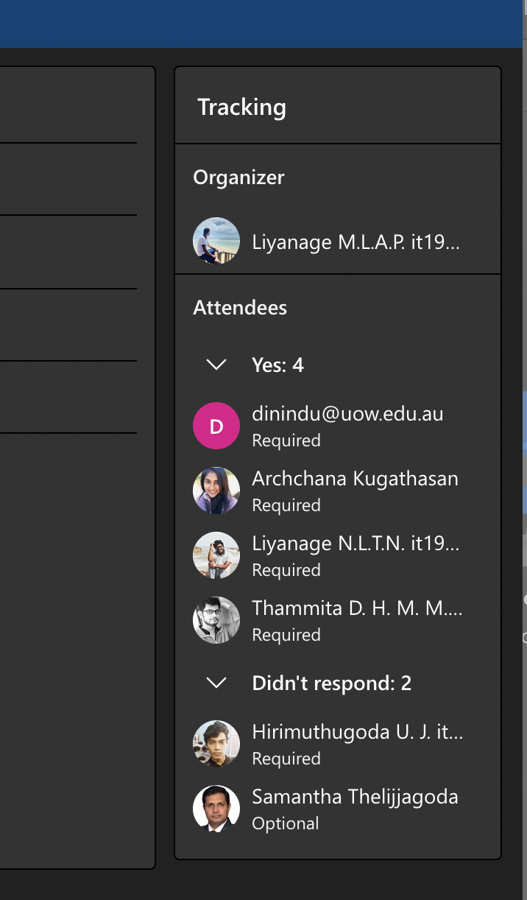

## Bi-weekly Group only discussions

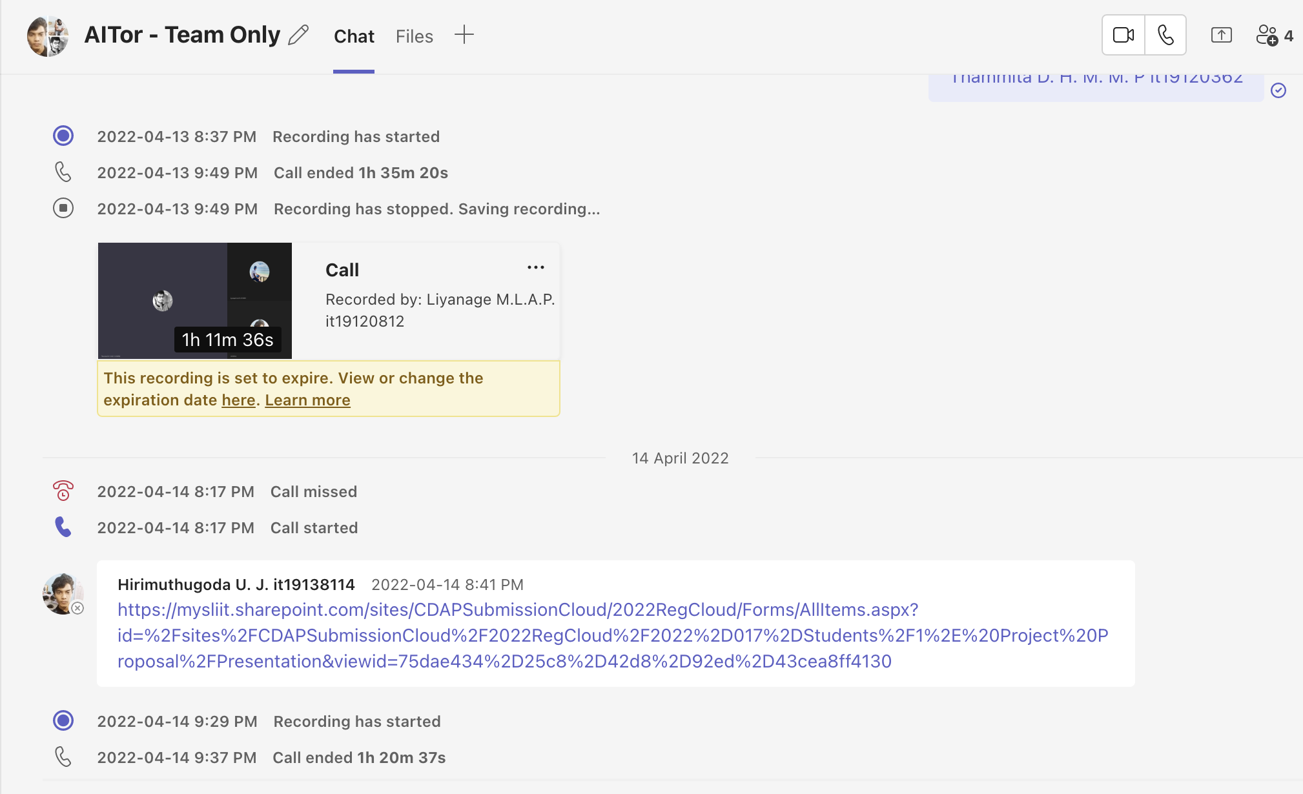

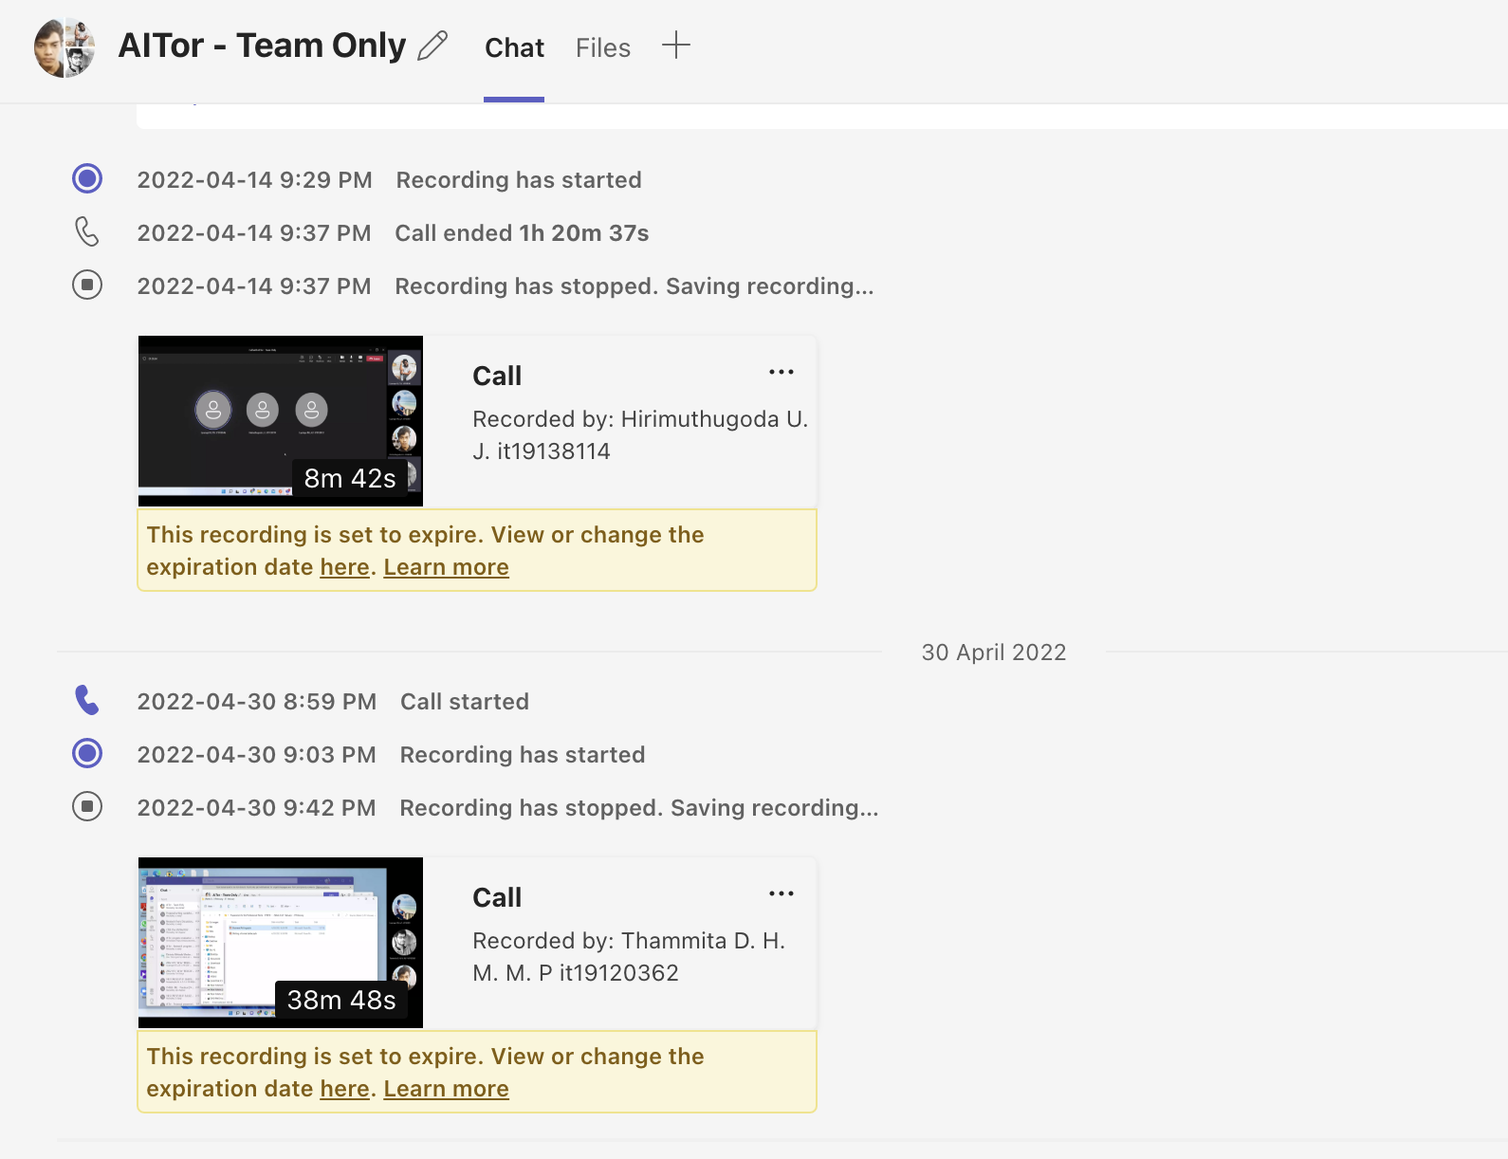

## Meetings with external supervisor

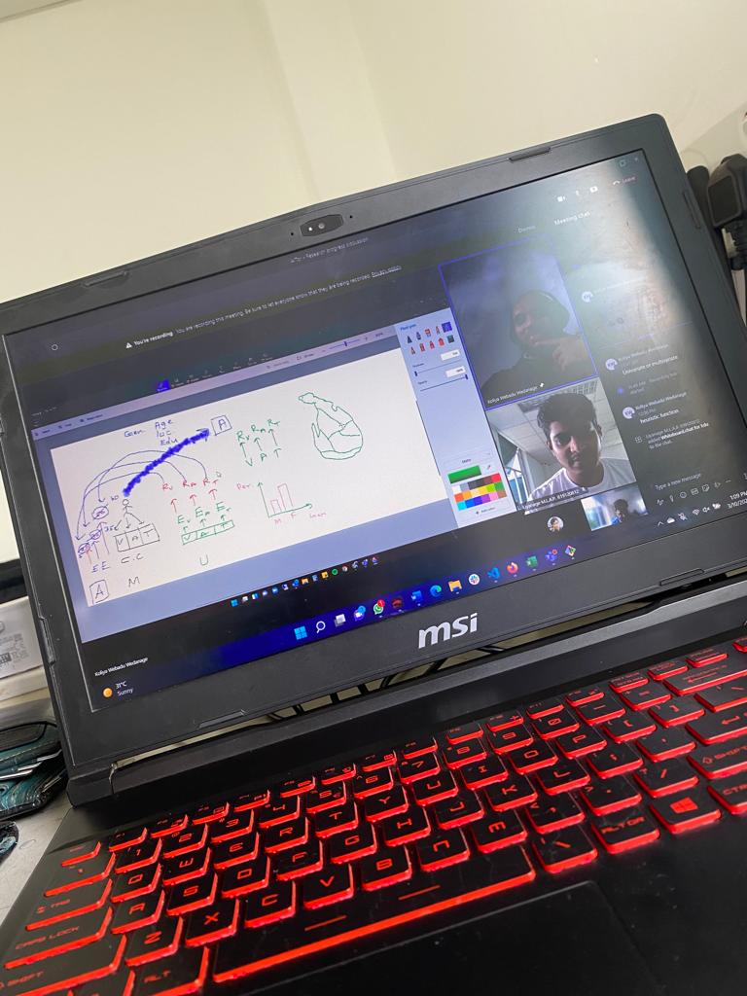

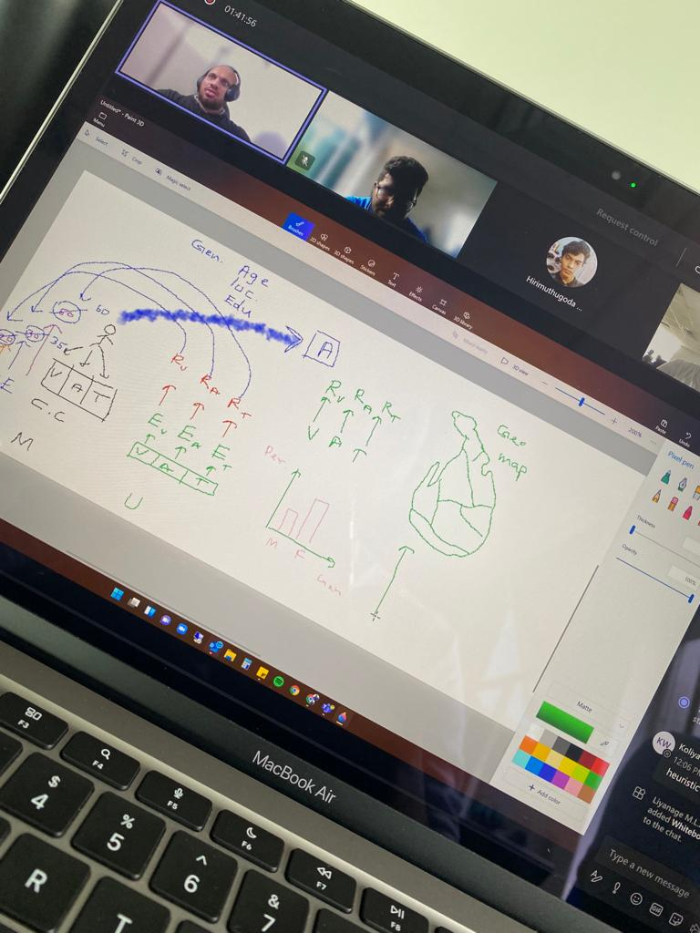

# Project planner

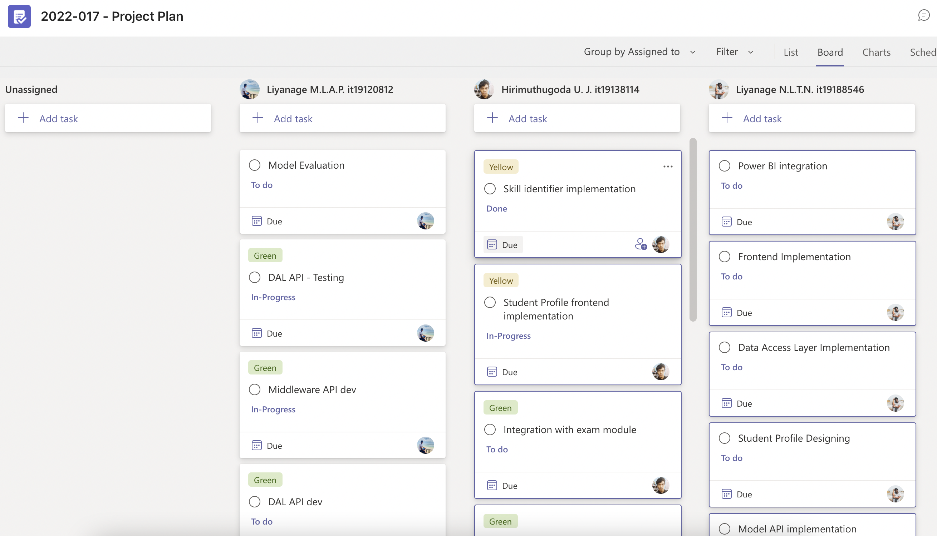

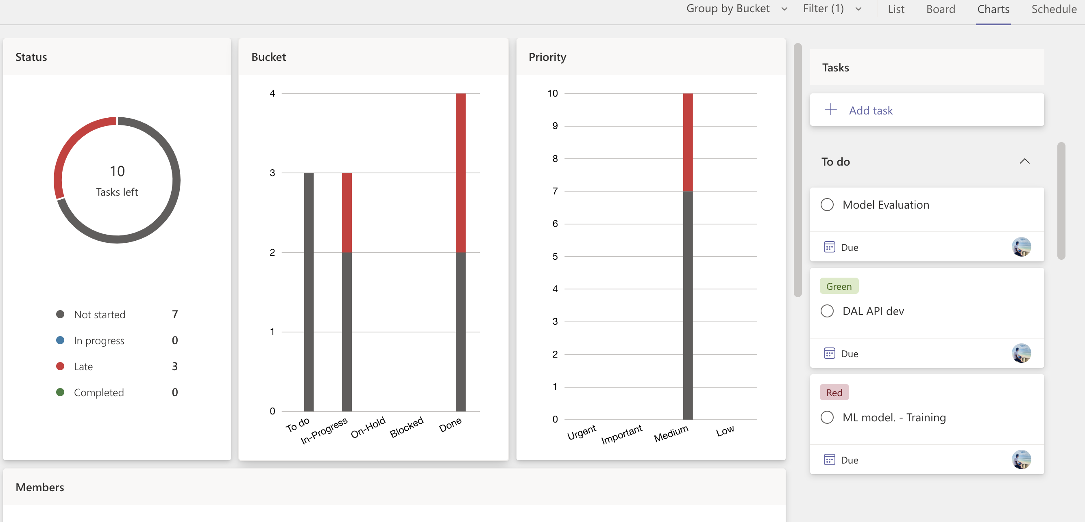

# Project Gantt chart



# Work breakdown chart

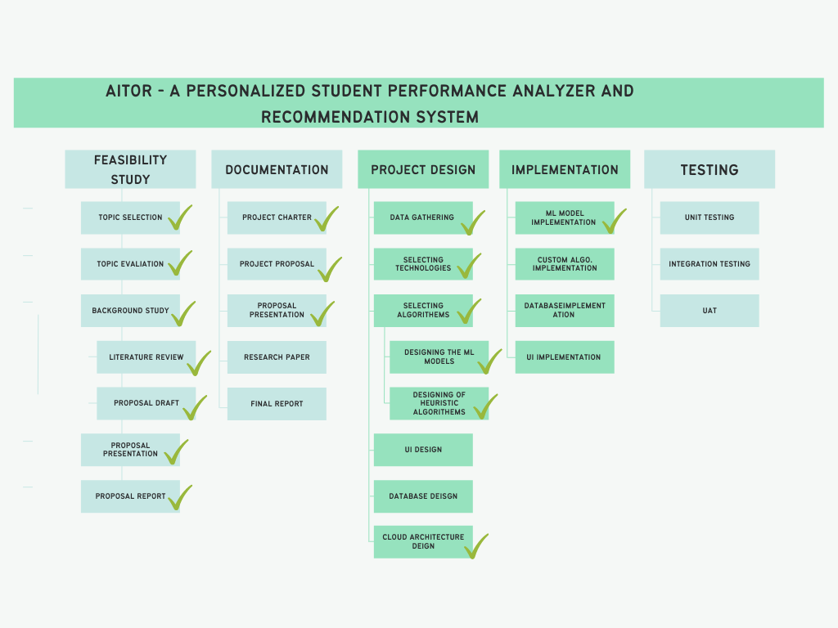

# User task allocation details

|  |  |  |
| --- | --- | --- |
| Allocated task | Predicted time | Actual time spent |
| Data gathering | 14/03/2022 – 31/03/2022 (18 days) | 18 days |
| Selecting algorithms and technologies | 17/03/2022 – 22/03/2022 (6 days) | 3 days |
| LS identification model | 1st week of April to 4th week of April | 4 weeks |

# 

# Code commits and GIT contributions

